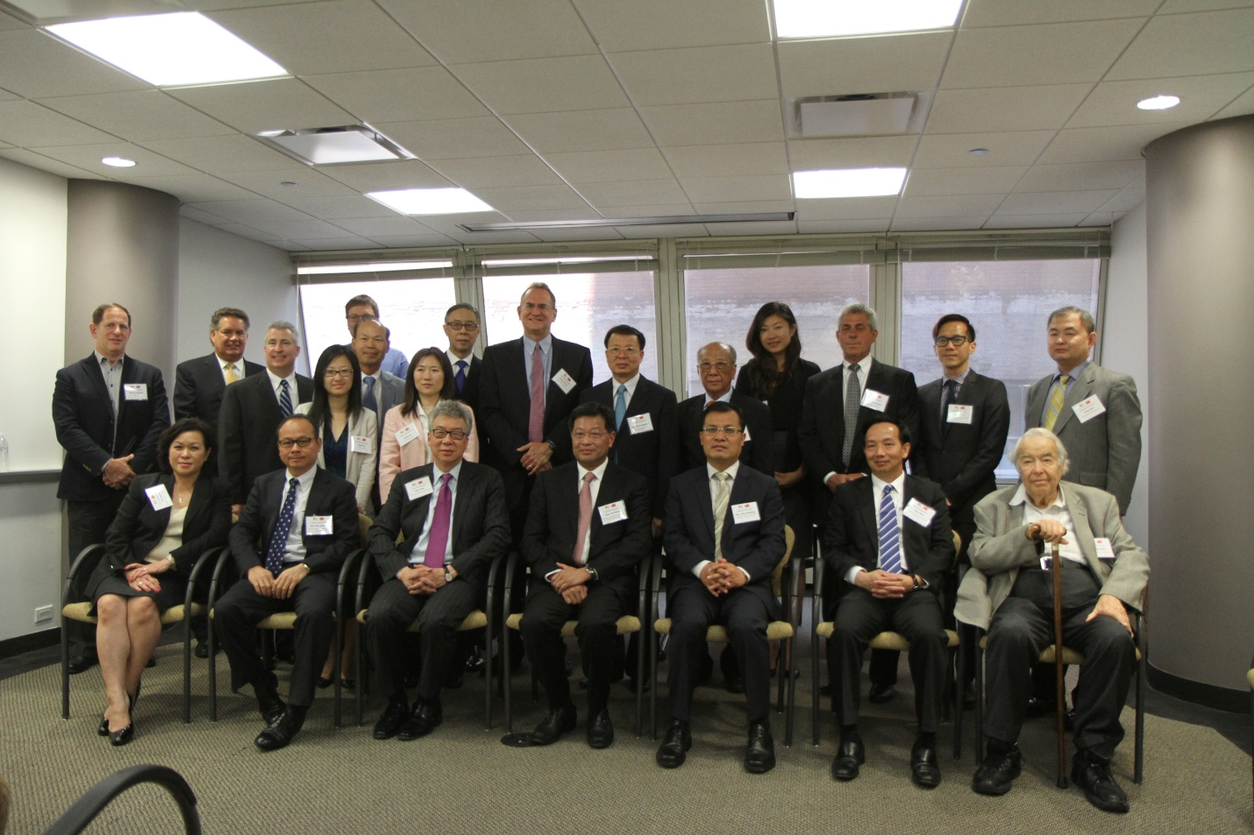
The US-China Chamber of Commerce (“USCCC”), in co-operation with the Guangdong Federation of Industry and Commerce / Guangdong General Chamber of Commerce (“GDGCC”), hosted a “Business Exchange and Commerce Agreement Signing Ceremony” in Chicago on June 9. The purpose of the event was to introduce GDGCC to members of USCCC and to further co-operation between USCCC and GDGCC to increase trade and investment activities between members of the two organizations. The event was held at the office of USCCC in Chicago. Over 20 corporate executives and professionals from the U.S. welcomed a high level delegation from GDCCC to Chicago.
The GDCCC delegation was led The Honorable Lin Xiong, Member, Standing Committee of Guangdong Provincial Party (Deputy Minister / Deputy Governor Rank) and Mr. Chen Dan, Chairman of GDCCC. The Honorable Zhao Weiping, Consul General of the People's Republic of China in Chicago attended the program and witnessed the Signing Ceremony.
Mr. Siva Yam, President of USCCC indicated in his opening remark that USCCC had over 20 years of co-operation with Guangdong Province including a long term co-marketing program with The Canton Fair, the world’s largest and oldest trade show. He said that Guangdong was the largest economy among all provinces and often labeled as “one step ahead of the rest of China.” “Guangdong is one of the most important places for Americans to do business with,” stated Mr. Yam. President Chen Dan pointed out Guangdong accounted for over 10%of the GDP and 10% of total retail sales in China. “With the change in government policy and business environment in China, this creates a lot of opportunities for American businesses,” stated Mr. Chen. Minister Lin Xiong concurred with Messrs. Yam and Chen regarding the business opportunities between the U.S. and Guangdong. He pointed out that there were about 6 million private enterprises in China with over 1.5 million were considered large-sized companies. “The initial foreign direct investments in Guangdong were from Hong Kong and Taiwan who were taking advantage of the low labor cost in China. As the manufacturing cost in China has risen, many foreign companies are moving their production to other low cost counties. Companies in Guangdong are now looking to upgrade their manufacturing and management technologies. We, the government, also strongly encourage companies to go abroad to become more internationalized. This creates spaces for co-operation,” said Minister Lin. First Business News (television), Sing Tao, World Journal, China Press, and China Journal were among the media that reported on the event.
六月九日，中美总商会(USCCC)与广东省工商联/广东省总商会(GDGCC)在芝加哥联合举办了“商贸交流会议与友好商会协议签字仪式”。此次会晤的目的是向中美总商会的会员介绍广东省总商会(GDGCC)、增进商会间未来合作、以促进两商会会员间贸易与投资活动。会议在中美总商会位于芝加哥的总部举行。二十余位来自美国企业的高层和专业人士热烈迎接中国高层访问团到访芝加哥。
广东省委常委、统战部部长林雄和广东省总商会(GDGCC)主席率领此次广东省经贸代表团。中华人民共和国驻芝加哥总领事馆总领事赵卫平也出席会议并见证了签字仪式。
中美总商会会长任剑浩先生在他的开幕致词中指出，中美总商会与广东省的合作往来已有20年之久，其中包括全球规模最大、历史最悠远的广交会市场合作长期计划。他还说，广东省是全国所有省份中最大的经济体，时常被认为“比中国其他城市先一步”。任先生表示，“广东省是美国企业合作中最重要的地方之一”。陈丹主席指出，广东省约占全国人民生产总值GDP的10%，约占全国零售总额的10%；“随着中国国家政策调整与市场环境变化，为美国企业制造了更多商业机会”。林雄常委赞成任剑浩先生与陈丹主席关于美国与广东之间商业机会的观点。他还指出，在中国约有六百万家私有企业，其中较大规模企业约有一百五十万家。林常委说，“在中国，早期的外来直接投资大多来自香港和台湾，享有中国廉价劳动力的优势。随着中国人工劳动力成本提升，许多外资企业选择将工厂迁至劳动力成本较为低廉的国家。广东的企业正在寻求生产与管理技术的升级。作为政府，我们强烈支持本土企业“走出去”并实现国际化；这为合作制造空间。”众多新闻媒体对此次活动进行报道，其中包括第一财经新闻电视、星岛日报、世界新闻、美国侨报以及神州传媒。

